**E-COMMERCE APPLICATION**

PHASE 1 : **Problem Definition and Design Thinking**

**PROBLEM DEFINITION**

The project at hand entails the creation of an artisanal e-commerce platform utilising IBM Cloud Foundry. The primary objective is to establish a platform that bridges skilled artisans with a global audience, showcasing their unique handmade products, and providing essential e-commerce functionalities such as secure shopping carts, seamless payment gateways, and an intuitive checkout process. This project encompasses designing the e-commerce platform, implementing necessary features, and ensuring a seamless user experience.

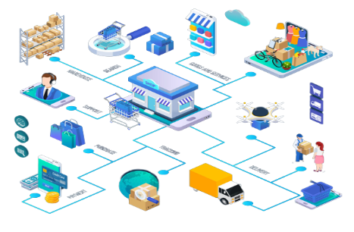

**OBJECTIVES:**

The project's goals include designing an intuitive platform layout, creating an efficient product database, ensuring secure user authentication, developing a user-friendly shopping experience, integrating secure payment gateways, and prioritising an appealing and user-friendly interface to enhance the overall artisanal e-commerce platform.

* **Platform Design**: Design the platform layout with sections for product categories, individual product pages, shopping cart, checkout, and payment.
* **Product Showcase:** Create a database to store product information such as images, descriptions, prices, and categories.
* **User Authentication:** Implement user registration and authentication features to enable artisans and customers to access the platform.
* **Shopping Cart and Checkout:** Design and develop the shopping cart functionality and a smooth checkout process.
* **Payment Integration:** Integrate secure payment gateways to facilitate transactions.
* **User Experience:** Focus on providing an intuitive and visually appealing user experience for both artisans and customers.

***E-COMMERCE APPLICATION ON IBM CLOUD FOUNDRY***

**1:Platform Design:**

The foundational step in building the artisanal e-commerce platform is to carefully design its layout.

*Product Categories:*

A well-organised display of product categories to allow users to easily browse and filter products based on their interests.

*Individual Product Pages:*

Dedicated pages for each product, showcasing detailed product information, high-quality images, pricing, and related products to encourage exploration.

*Shopping Cart:*

A user-friendly shopping cart feature that allows customers to review and manage their selected items before proceeding to checkout.

*Checkout:*

A streamlined and intuitive checkout process with minimal steps to reduce cart abandonment rates.

*Payment:*

Integration of secure payment gateways to facilitate seamless and secure transactions.

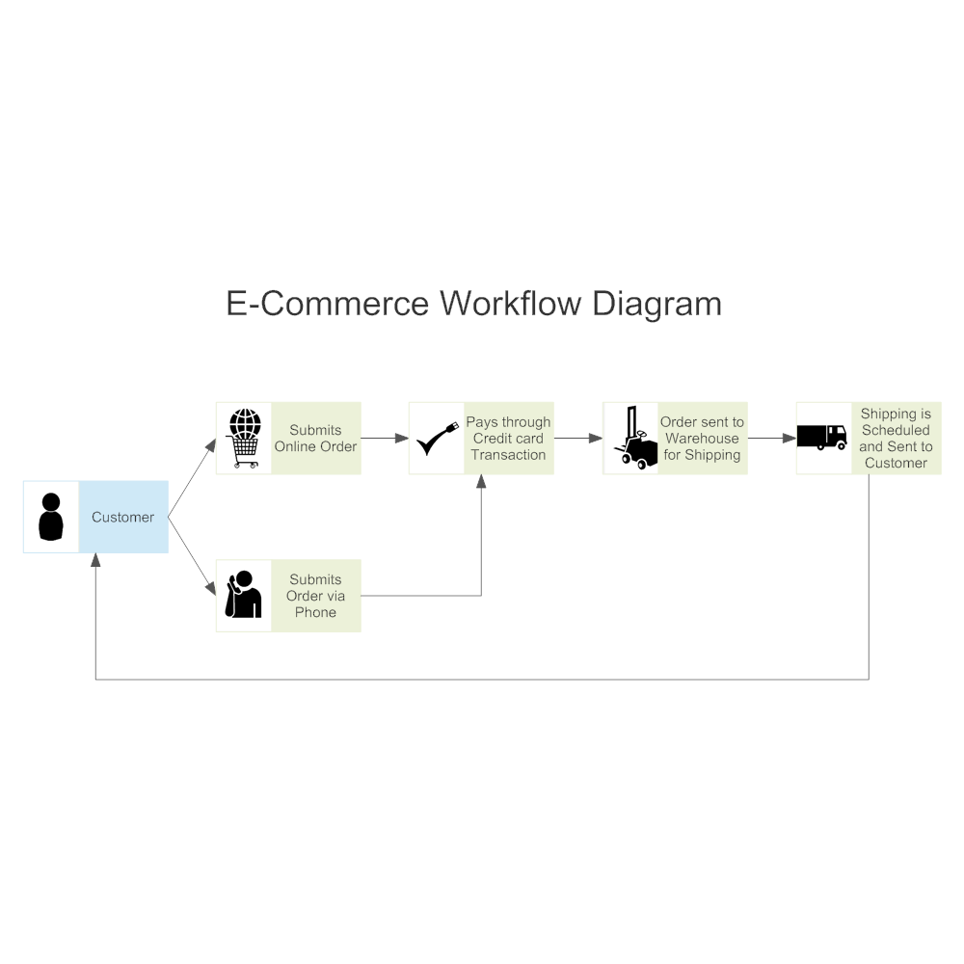

**2.Product Showcase:**

An integral part of the platform's success is the ability to effectively showcase artisanal products. To achieve this, we will:

*Create a Database:*

Develop a robust database system to efficiently store and manage product information. This database will include fields for product images, detailed descriptions, accurate pricing, and categorization.

*Search and Filter Functionality*:

Implement a search and filter feature to assist users in discovering products based on their preferences, such as category, price range, and artisan information.

**3.User Authentication:**

To ensure secure access and interaction on the platform, we will incorporate user authentication features:

*User Registration:*

Allow artisans and customers to register accounts, providing necessary details for identification and communication.

*Authentication:*

Implement secure login mechanisms, including multi-factor authentication for enhanced security.

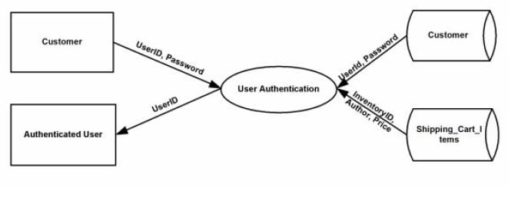

**4.Shopping Cart and Checkout:**

A seamless shopping cart and checkout process is crucial for a positive user experience:

*Shopping Cart Functionality:*

Develop a dynamic shopping cart that displays real-time updates, including item quantities and totals. Allow users to easily add, remove, or modify items within the cart.

**5.Payment Integration:**

Secure and reliable payment processing is vital for the success of an e-commerce platform:

*Payment Gateway Integration:*

Integrate reputable payment gateways to support various payment methods, including credit cards, digital wallets, and more. Ensure compliance with security standards to protect user data.

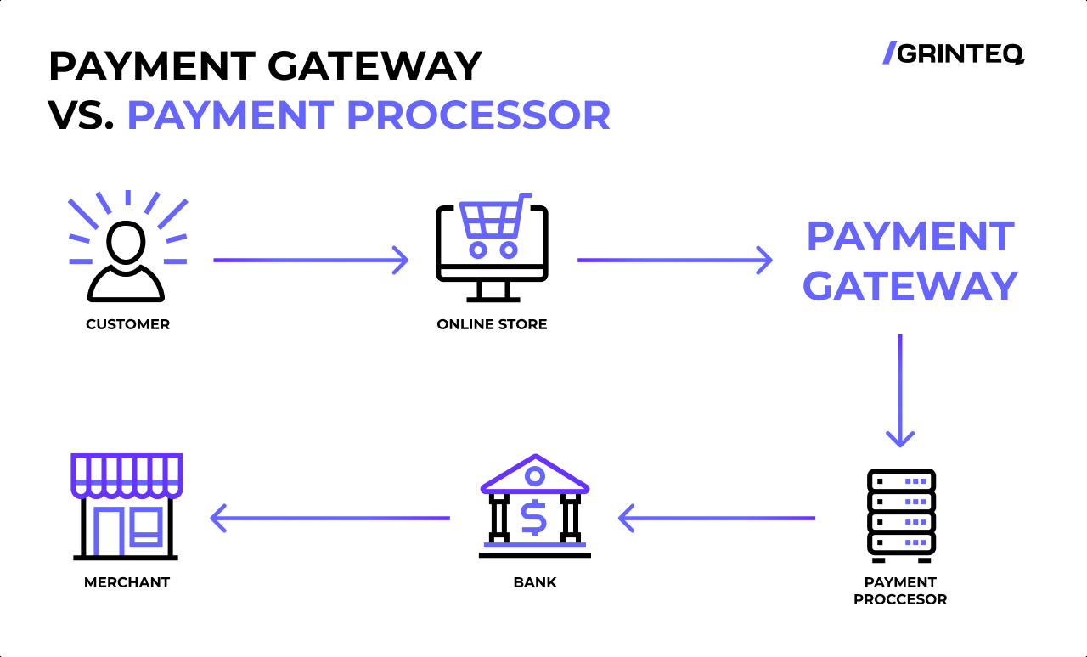

**6.User Experience:**

A delightful and user-friendly experience is at the core of our design thinking:

*Intuitive Navigation:*

Implement intuitive navigation menus and user interfaces to make browsing and shopping effortless.

*Mobile Responsiveness:*

Ensure that the platform is accessible and functional on various devices, including smartphones and tablets.*Performance Optimization:*

Focus on optimising page load times and overall performance to keep users engaged and satisfied.